Lab Assignment: 4
SQL User Management & Access Control
Title: Implementation of User Creation, Deletion, and Privilege Management in SQL

Problem Statement :Design and execute SQL commands to create users, manage their access privileges, and remove users in a database system. This assignment focuses on database security and access control mechanisms.

Tasks
Part A: User Creation
- Create a new user named user1 with a password

. 2. Create another user user2 with limited access.

Part B: Granting Privileges
- Grant SELECT and INSERT privileges on a table Student to user1

. 4. Grant ALL privileges on a table Course to user2.

5. Provide WITH GRANT OPTION to user1 and observe its effect.
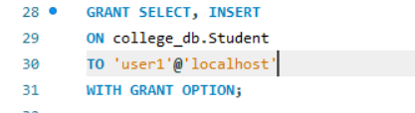

Part C: Revoking Privileges
6. Revoke INSERT permission from user1 on the Student table.
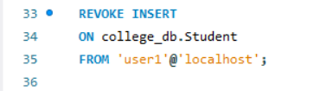
7. Revoke all privileges from user2 on the Course table.


Part D: User Deletion
8. Drop/Delete user user2 from the database.
9. Attempt to login using deleted credentials and observe the result.
Observation:
After deleting the user using DROP USER, login attempt with the same credentials failed with an "Access denied" error.

Part E: Additional Commands
10. Display all users in the system.
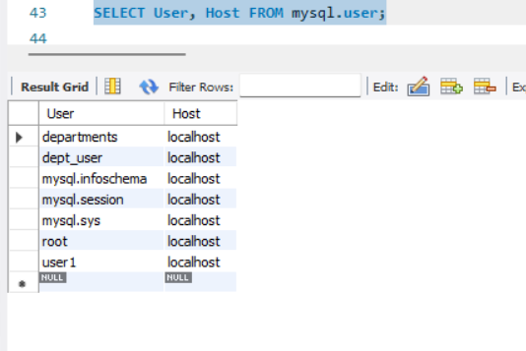
11. Show privileges assigned to a specific user.

